1. 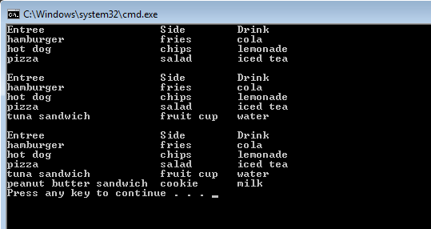Create an application named LunchDemo that declares several Lunch objects and includes a display method to which you can pass different numbers of Lunch objects in successive method calls. The Lunch class contains auto-implemented properties for an entree, side dish, and drink.
2. The store manager wants to know how much money and how many items have gone through all his cash registers today. Update or make a copy of the CashRegister class from last week to now have a two static variables, one to hold the total cash amount from all CashRegister objects the second to hold the total number of items from all CashRegister objects. Update the class as appropriate so these two new static variables are updated anytime any Cash Register handles an item. Output these total results.

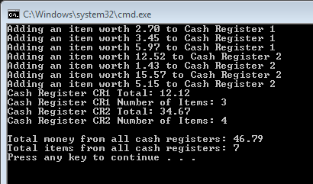

1. Create a program named **SchoolsDemo** that allows a user to enter data about five School objects and then displays the School objects. The School class contains fields for the School name and number of students enrolled and properties for each field.

Amend the program so that schools can be displayed in order or enrolment. We have not covered this yet so you may need to do some research yourself!

